**TASK 1 – MATHEMATICS – WHY MATHS IN CODING?**

**1.A**

**OUTPUT:**

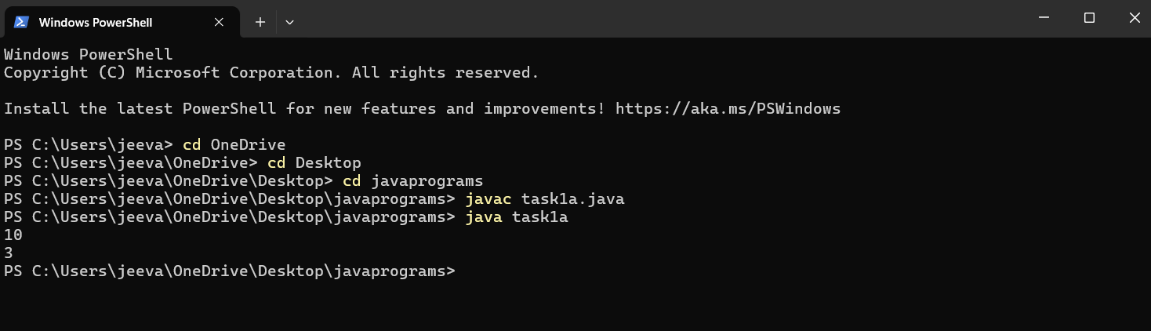

**1.B**

**OUTPUT:**

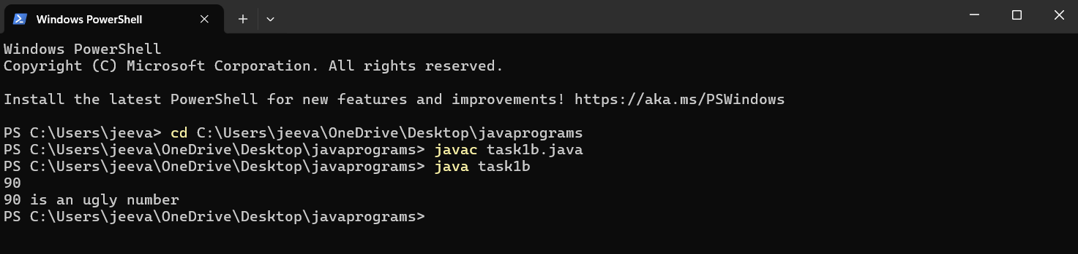

**1.C**

**OUTPUT:**

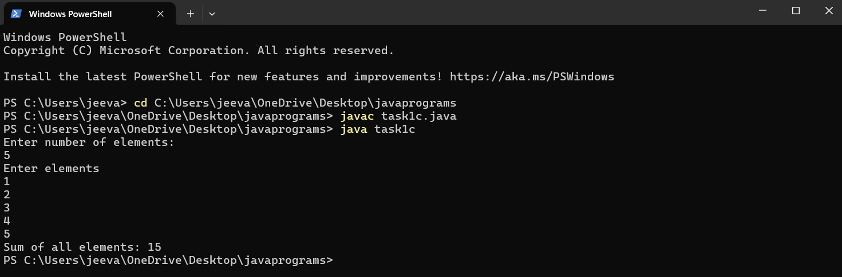

**TASK NO: 2 :- ADVANCED CONCEPTS ON ARRAY :**

**2.A**

**OUTPUT:**

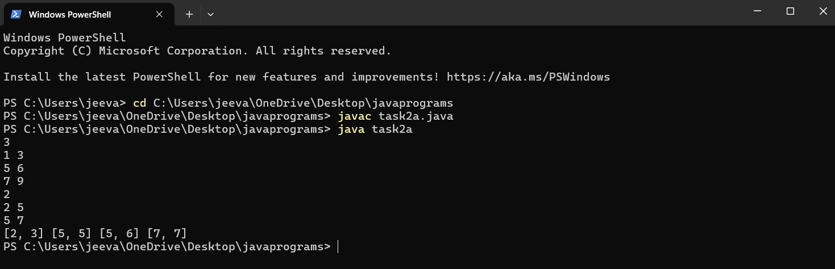

**2.B**

**OUTPUT:**

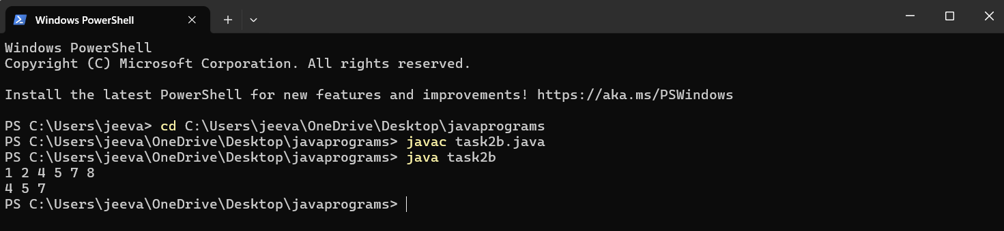

**2.C**

**OUTPUT:**

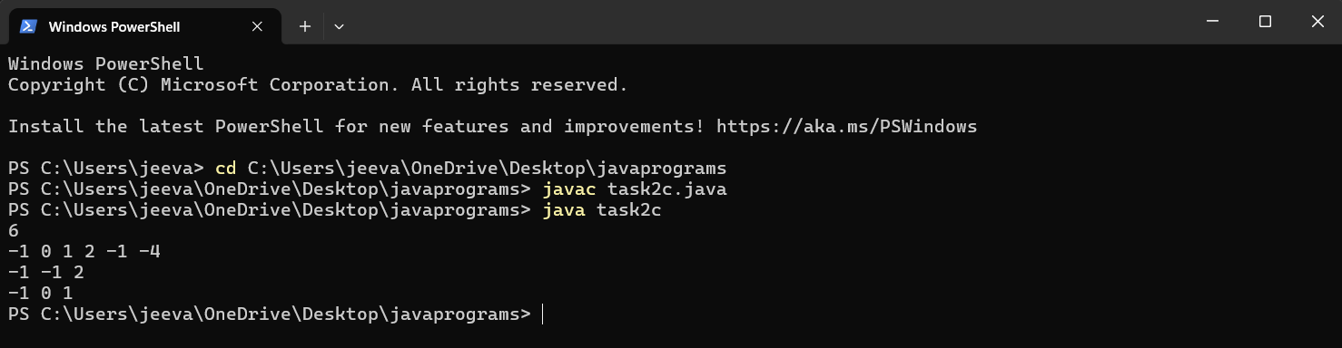

**TASK 3 : ADVANCED CONCEPTS ON STRINGS**

**3.A**

**OUTPUT:**

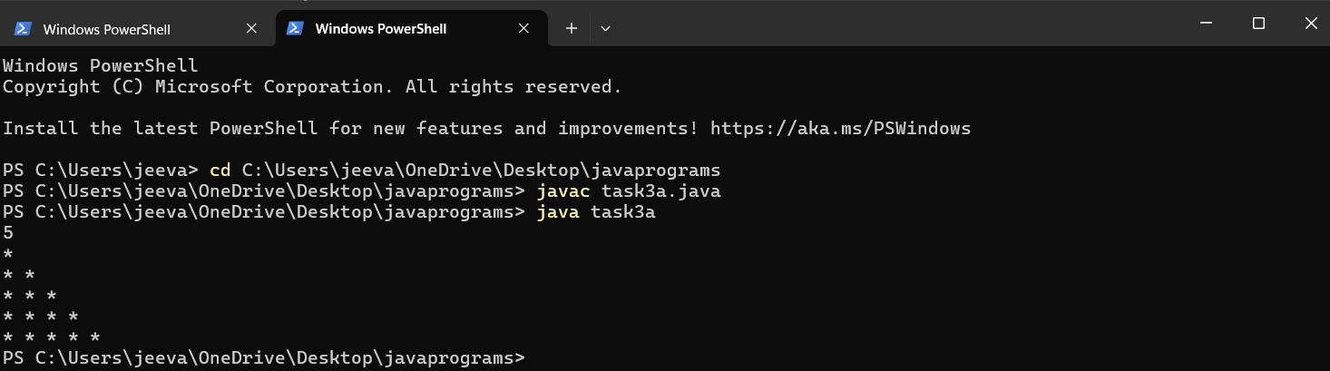

**3.B**

**OUTPUT:**

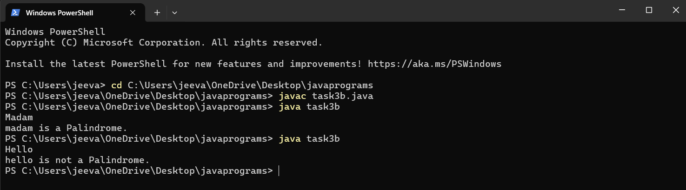

**3.C**

**OUTPUT:**

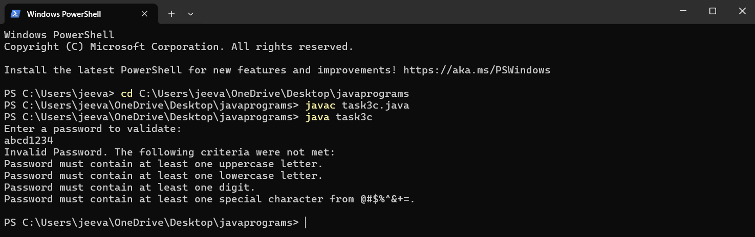

**TASK 4 : STACK AND QUEUES**

**4.A**

**OUTPUT:**

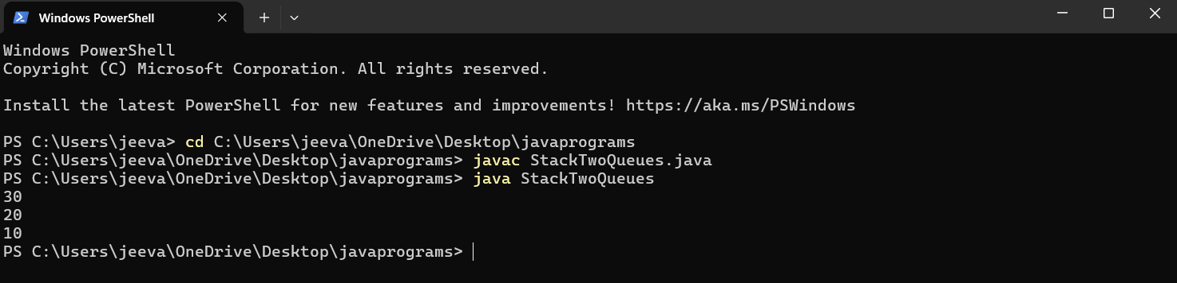

**4.B**

**OUTPUT:**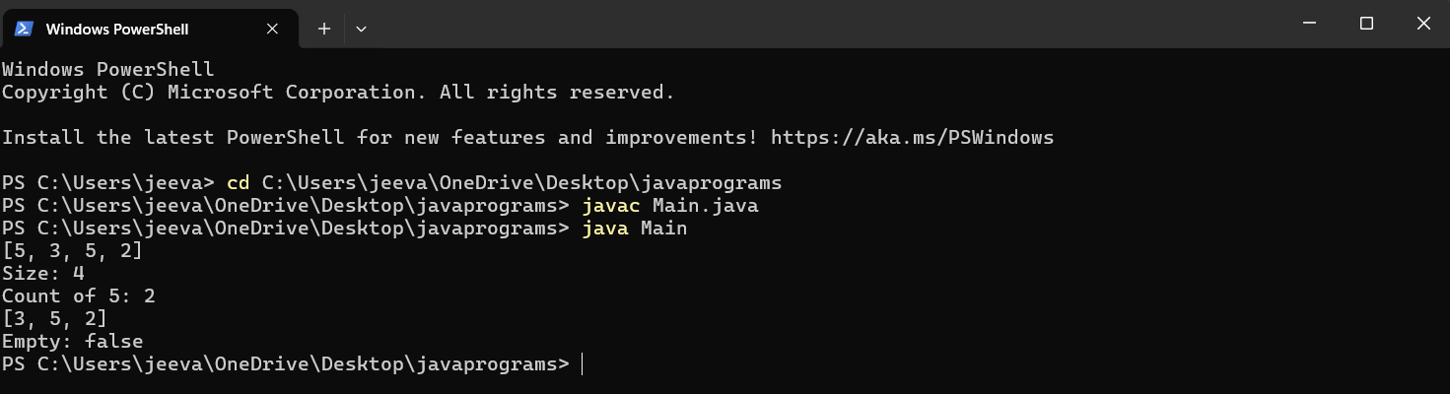

**4.C**

**OUTPUT:**

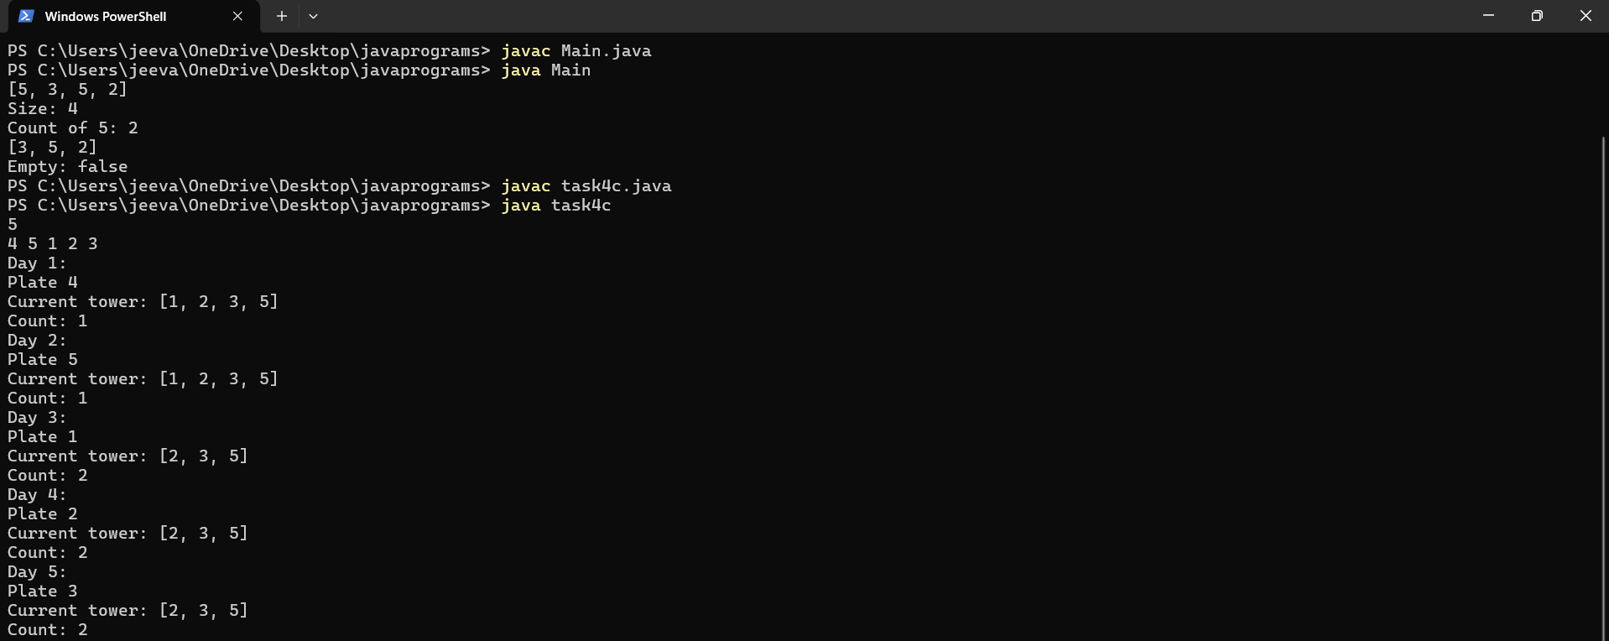

**Task 5: Linked List-Single linked list, Doubly liked list, operations on linked list.**

**5.a**

**OUTPUT:**

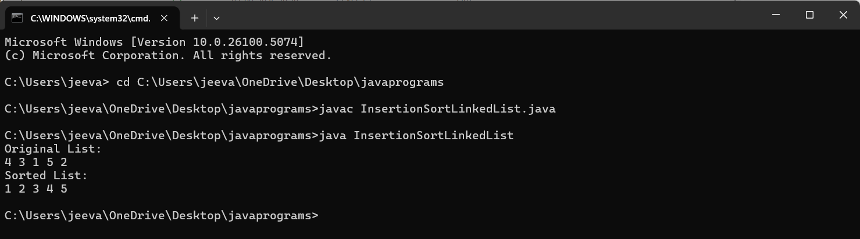

**5.B**

**OUTPUT:**

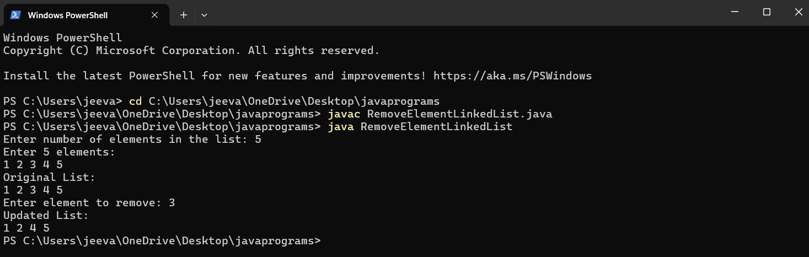

**5.C**

**OUTPUT:**

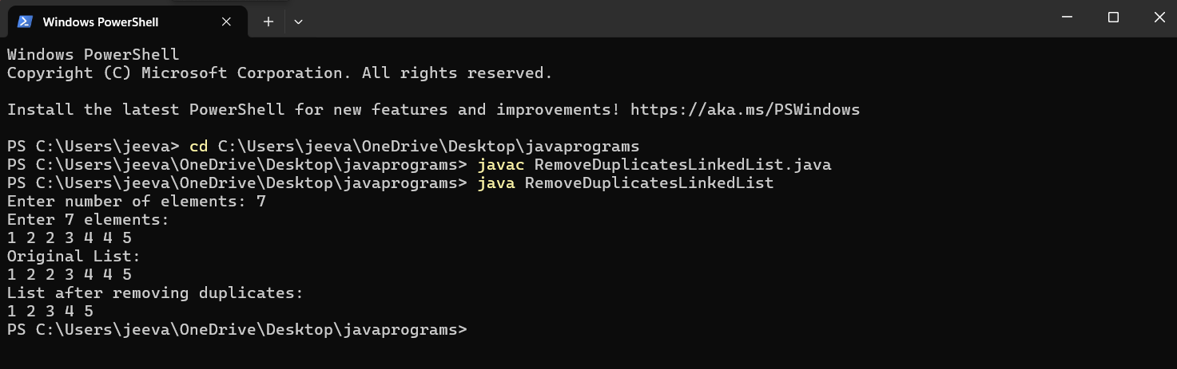

**Task 6: Sorting- Counting sort, Radix sort, Heap sort, Bucket sort**

**6.a**

**OUTPUT:**

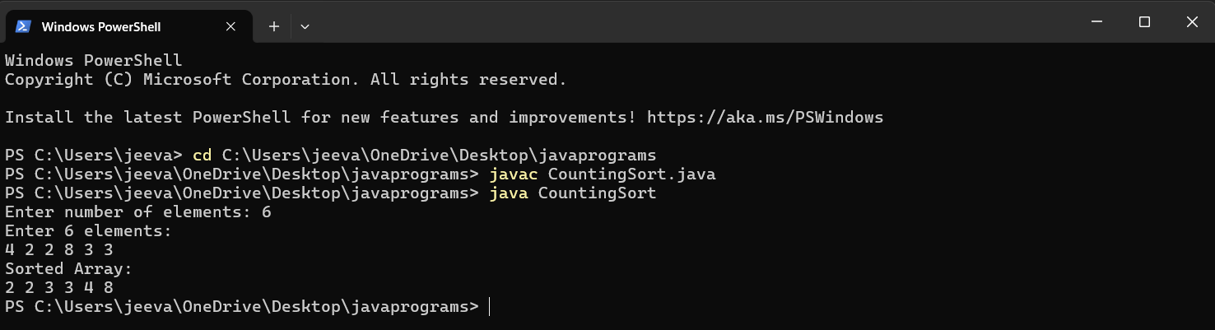

**6.B**

**OUTPUT:**

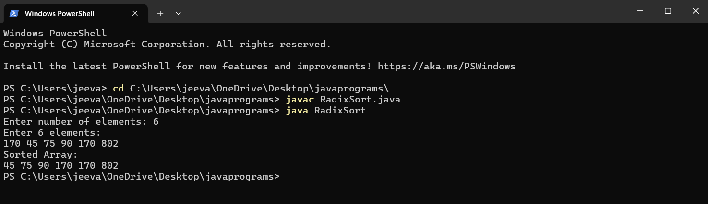

**6.C**

**OUTPUT:**

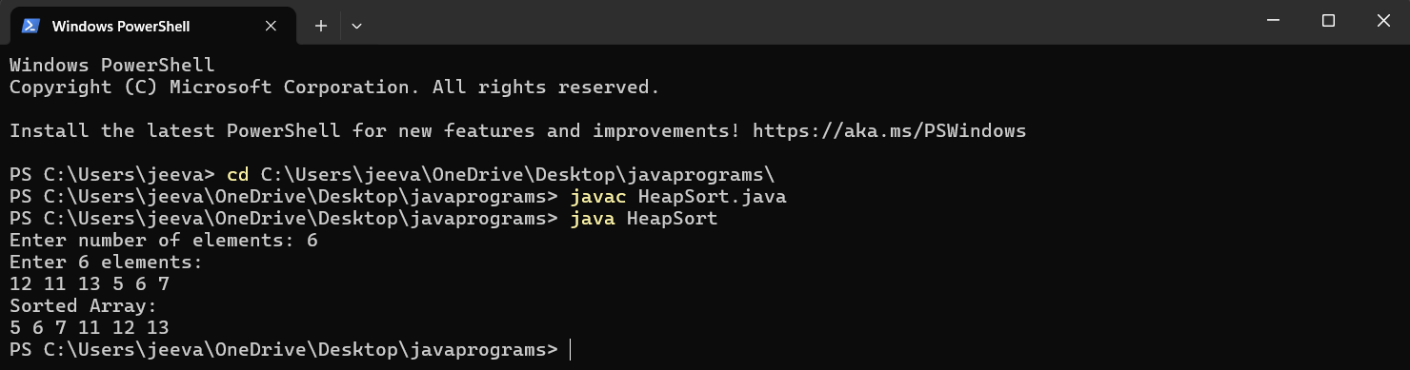

**Task 7: Introduction, tree traversal (in-order, pre-order, post-order), Binary search tree**

**7.A**

**OUTPUT:**

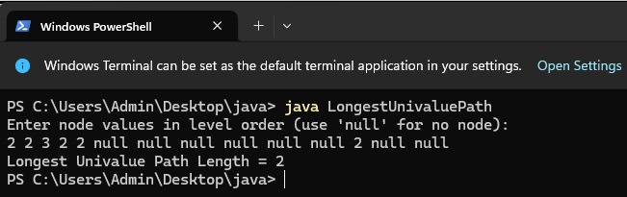

**7.B**

**OUTPUT:**

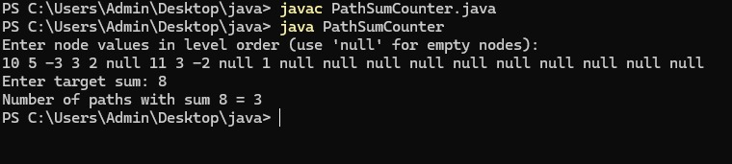

**7.C**

**OUTPUT:**

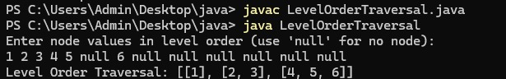

**Task 8: Graph - Introduction Adjacency Matrix and List, Depth First search, Breadth First Search, Manacher’s algorithm**

**8.A**

**OUTPUT:**

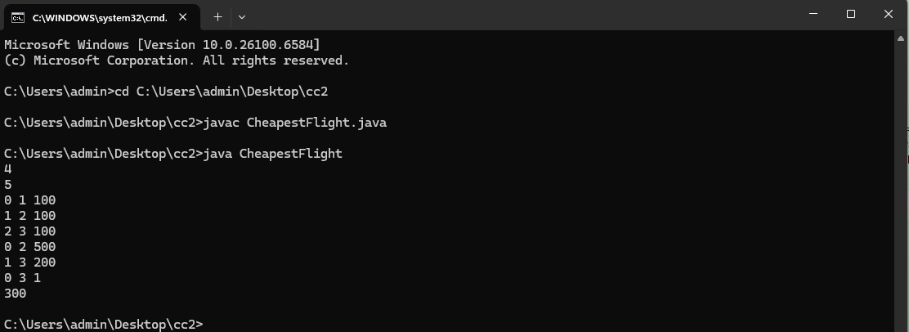

**8.B**

**OUTPUT:**

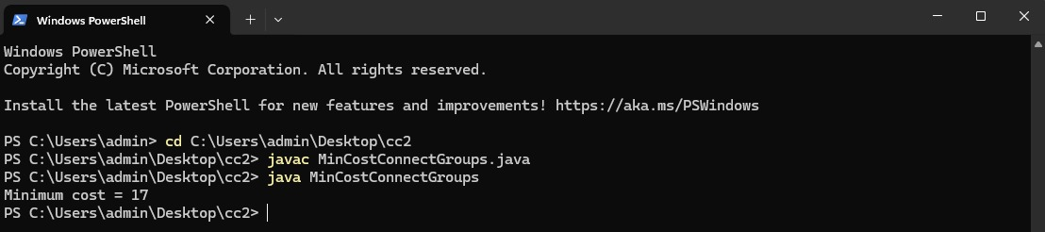

**8.C**

**OUTPUT:**

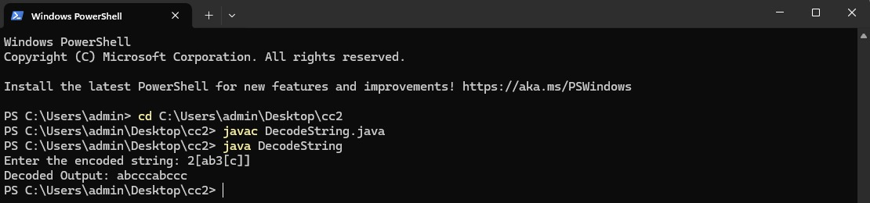

**Task 9: Backtracking-Introduction, Backtrack vs Divide and Conquer:**

**9A**

**OUTPUT:**

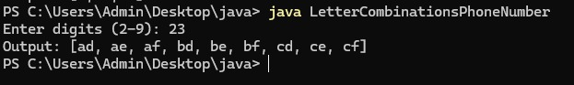

**9.B**

**OUTPUT:**

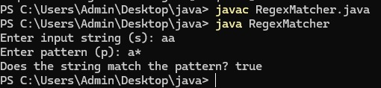

**9.C**

**OUTPUT:**

